DSP EXPERIMENTS
NAME:N.ALGIPRAN(192512494)
COURSE NAME & CODE:ECA0901-DIGITAL SIGNAL PROCESSING

Expt 6 | Finite Word length Effects
 | 6.1 Uniform Quantization and Quantization Error Analysis of a Discrete-Time Sinusoidal Signal Using MATLAB

Objectives:

- To generate a discrete-time sinusoidal signal in MATLAB.
- To perform uniform quantization with different quantization levels.
- To compare the original and quantized signals.
- To analyze the quantization error and its effect on signal quality.

Procedure
- Open MATLAB and create a new script file.
- Define the sampling frequency, signal frequency, and time vector.
- Generate a discrete-time sinusoidal signal using the sine function.
- Select different quantization levels such as 8, 16, and 32 levels.
- Apply uniform quantization to the generated signal for each quantization level.
- Compute the quantization error by subtracting the quantized signal from the original signal.
- Calculate the Mean Square Error (MSE) to evaluate the quantization performance.
- Plot the original signal and the quantized signals for comparison.
- Plot the quantization error signals corresponding to each quantization level.
- Analyze the effect of increasing quantization levels on signal quality and error reduction.

Program (Matlab code)
clc; clear; close all;
%% Signal
fs = 1000; f = 50;
t = 0:1/fs:0.1;
x = sin(2*pi*f*t);
%% Quantization Levels L = [8 16 32];
colors = {'r','g','m'}; figure;
for i = 1:length(L)
% Quantization
xq{i} = round((x+1)(L(i)-1)/2)(2/(L(i)-1)) - 1;

% Error & MSE e{i} = x - xq{i};
mse(i) = mean(e{i}.^2);

% Plot Quantized Signals subplot(4,1,i+1); stairs(t,xq{i},colors{i},'LineWidth',1.2);
title(['Quantized Signal (' num2str(L(i)) ' Levels)']); grid on;
end

% Original Signal subplot(4,1,1); plot(t,x,'LineWidth',1.5); title('Original Signal'); grid on;

% Display MSE
fprintf('MSE for 8 Levels = %f\n', mse(1)); fprintf('MSE for 16 Levels = %f\n', mse(2)); fprintf('MSE for 32 Levels = %f\n', mse(3));

%% Error Plots figure;
for i = 1:3 subplot(3,1,i);
plot(t,e{i});
title(['Error (' num2str(L(i)) ' Levels)']); grid on;
end

Output:
Objective 1:
Input:
- Sampling Frequency, 𝐹_{𝑠} = 1000Hz
- Signal Frequency, 𝑓 = 50Hz
- Time Duration = 0.1 s

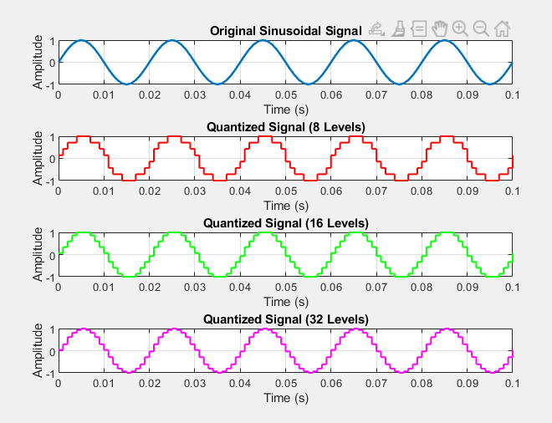

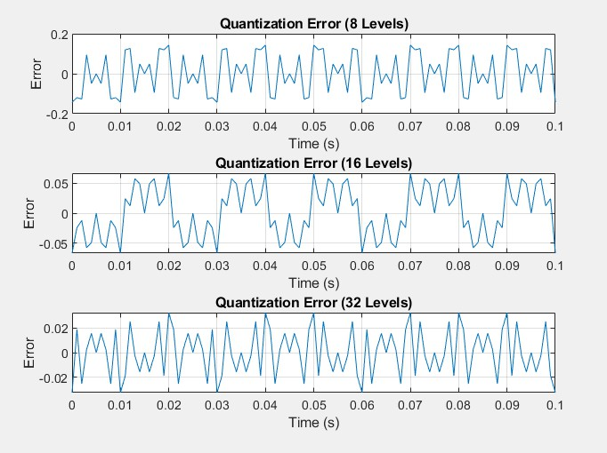

Result:
- A discrete-time sinusoidal signal was successfully generated in MATLAB.
- Uniform quantization was performed for different quantization levels, and the corresponding quantized signals were obtained.
- Comparison of the original and quantized signals showed that the quantized signal approximates the original signal more closely as the number of quantization levels increases.
- The quantization error was analyzed and found to decrease with increasing quantization levels, resulting in improved signal quality and reduced quantization noise.

Expt 6 | Finite Word length Effects
Date: | 6.2 Analysis of Finite Word Length Effects in Digital Signal Representation Using Truncation and Rounding Techniques in MATLAB

Objectives:
- To represent a digital signal using a finite word length format in MATLAB.
- To perform truncation and rounding operations on the finite word length representation of the signal.
- To evaluate and compare the errors resulting from truncation and rounding techniques.
- To investigate the impact of finite precision arithmetic on the accuracy of digital signal representation.

Procedure
- Open MATLAB and create a new script file.
- Define the sampling frequency, signal frequency, and time vector.
- Generate a discrete-time sinusoidal signal using the MATLAB sin() function.
- Select an appropriate finite word length (e.g., 8 bits) for representing the signal samples.
- Scale the signal according to the selected word length to obtain a finite-precision representation.
- Apply the truncation operation using the fix() function to remove the fractional part of the scaled signal samples.
- Apply the rounding operation using the round() function to round the scaled signal samples to the nearest integer value.
- Convert the truncated and rounded samples back to their original amplitude range by dividing them by the scaling factor.
- Compute the truncation error by subtracting the truncated signal from the original signal.
- Compute the rounding error by subtracting the rounded signal from the original signal.
- Calculate the Mean Square Error (MSE) and maximum error for both truncation and rounding operations.
- Compare the error values obtained from truncation and rounding.
- Analyze the effect of finite word length on signal representation and evaluate which method provides better accuracy.
Program (Matlab code): clc; clear; close all n=0:79;
x=sin(2*pi*n/40); q=8;
xt=floor(x*q)/q; xr=round(x*q)/q;

et=x-xt; er=x-xr;
% Fig 1 figure
plot(n,x,'b',n,xr,'r','LineWidth',1.5) grid on
title('Original vs Quantized') legend('Original','Quantized')
% Fig 2 figure
plot(n,x,'b',n,xt,'r',n,xr,'g','LineWidth',1.5) grid on
title('Truncation vs Rounding') legend('Original','Truncated','Rounded')
% Fig 3 figure stem(n,et,'r') hold on stem(n,er,'g') grid on
title('Quantization Error') legend('Truncation','Rounding')
% Fig 4 figure
bar([mean(et.^2) mean(er.^2)]) set(gca,'XTickLabel',{'Truncation','Rounding'}) grid on
title('MSE Comparison') ylabel('MSE')

Output:
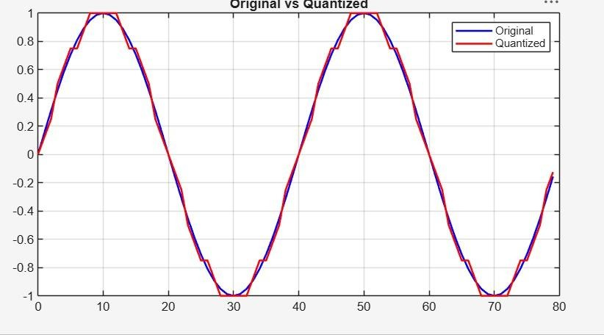

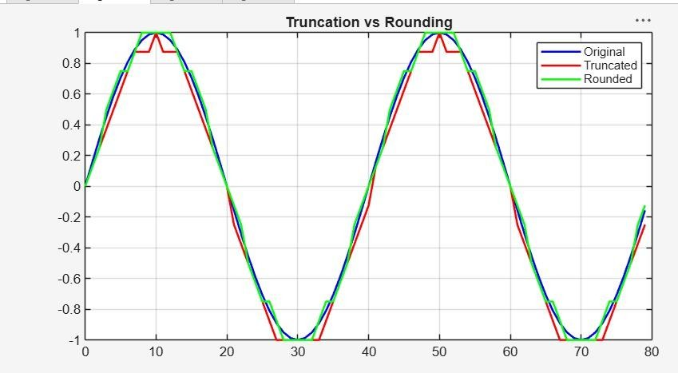

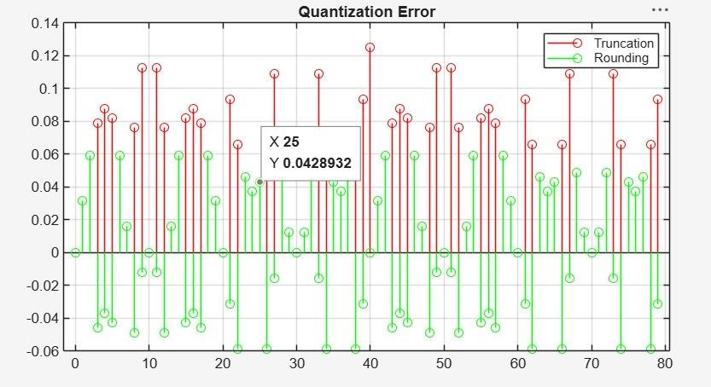
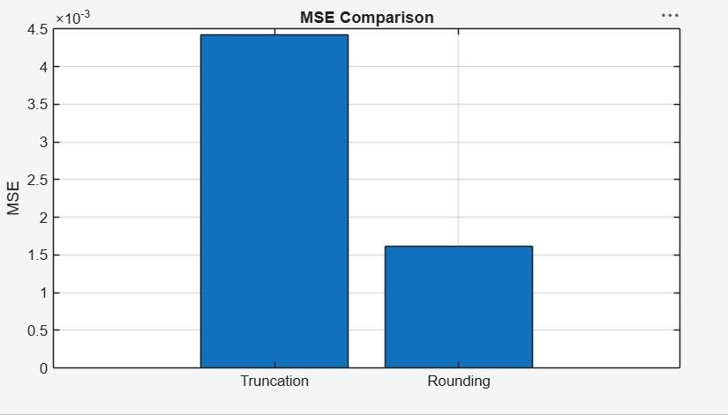

Result:
- The digital signal was successfully represented using a finite word length format in MATLAB.
- Truncation and rounding operations were implemented on the signal samples.

- The errors introduced by truncation and rounding were computed and compared, showing that rounding generally produces smaller errors than truncation.
- The effect of finite precision on signal representation was analyzed, demonstrating that reduced word length increases representation error and may affect signal accuracy.

